Task 1:Working with SNS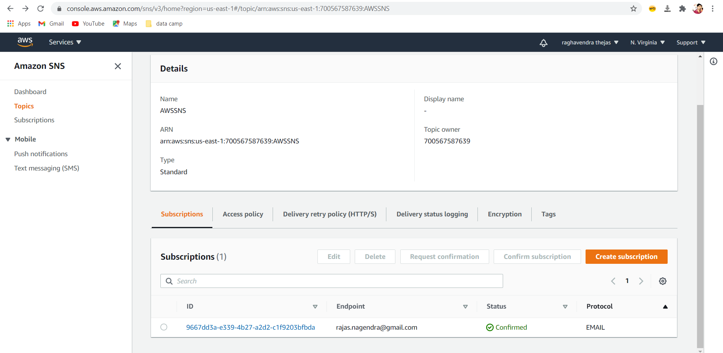

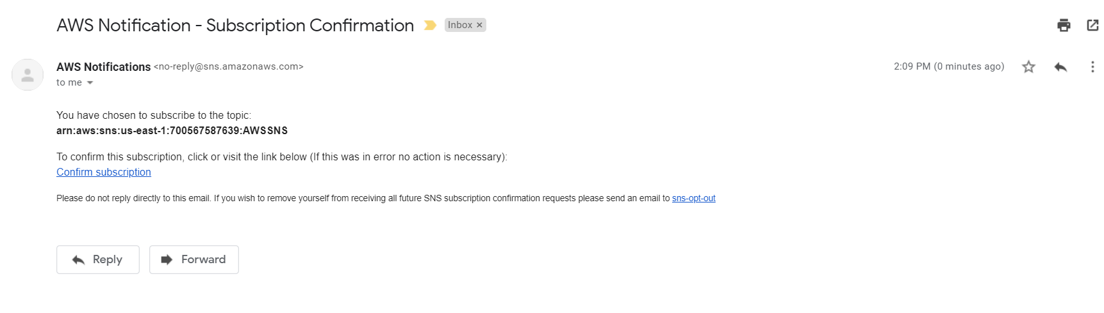

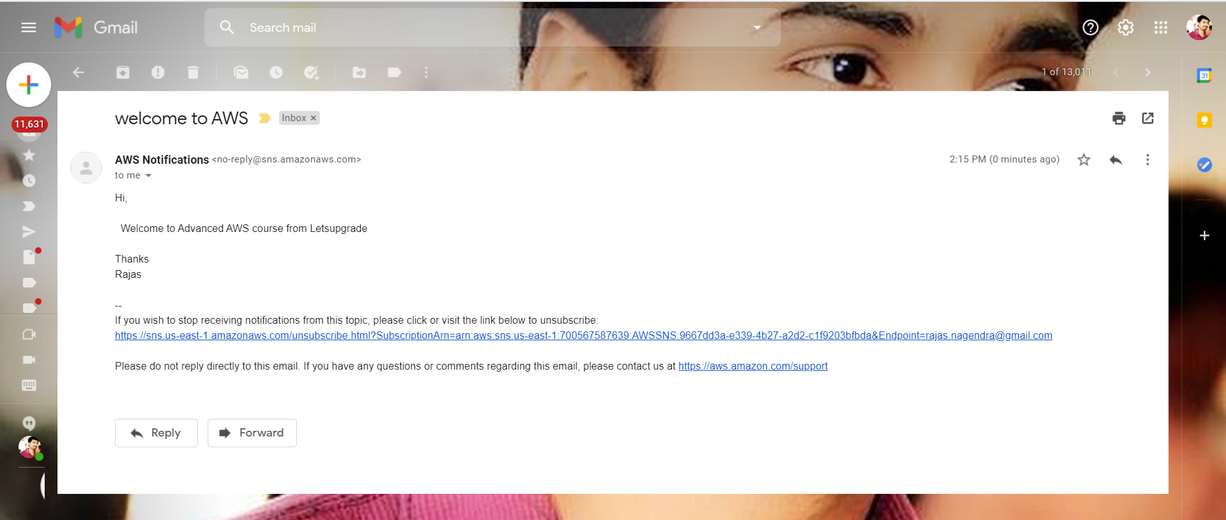

Next page

Task 2 :Working with SQS

ss1:sqs console

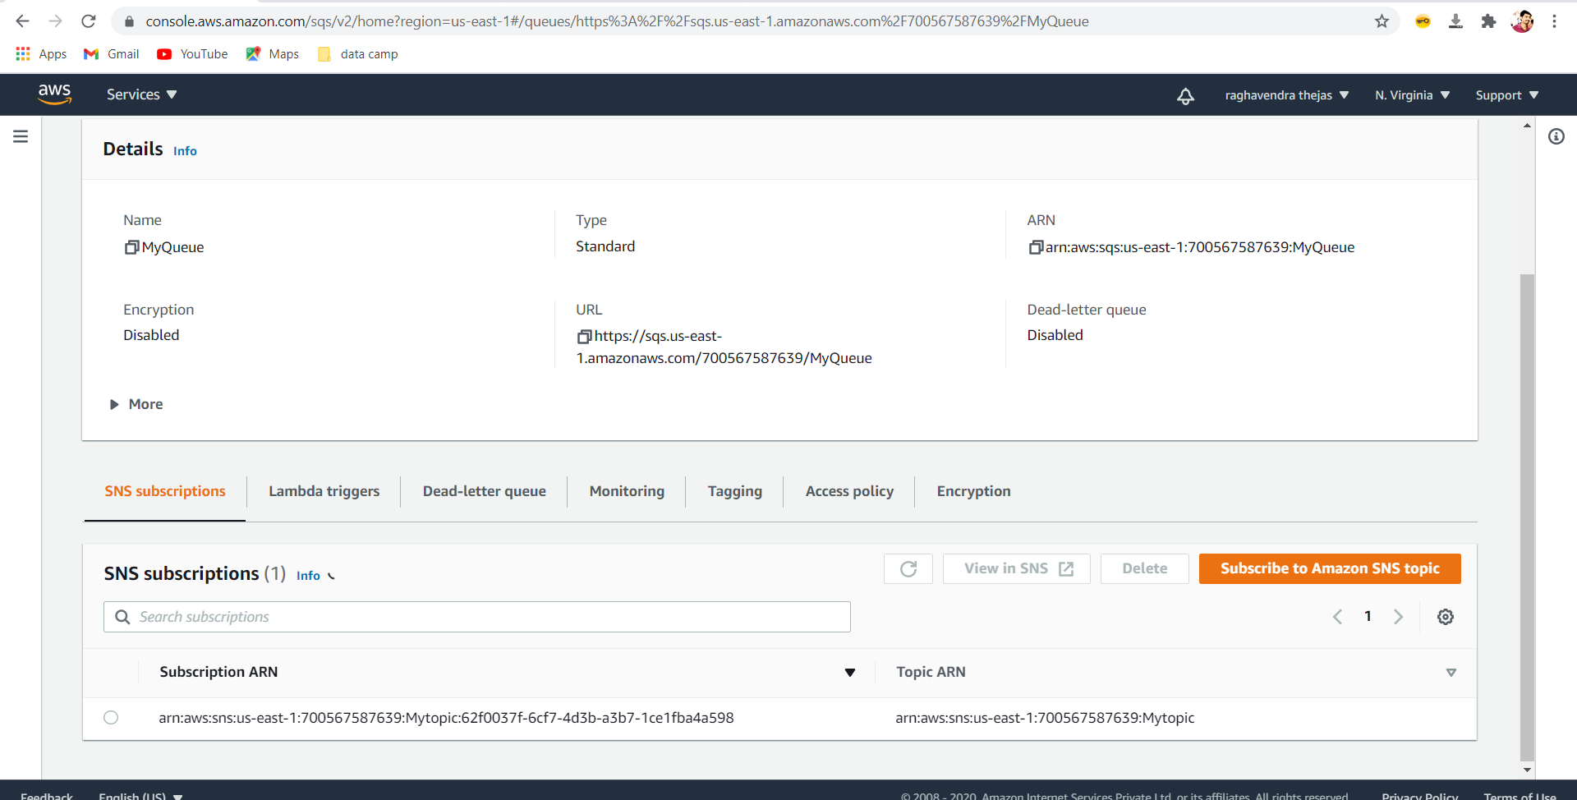

ss2: poll for messages and display message window

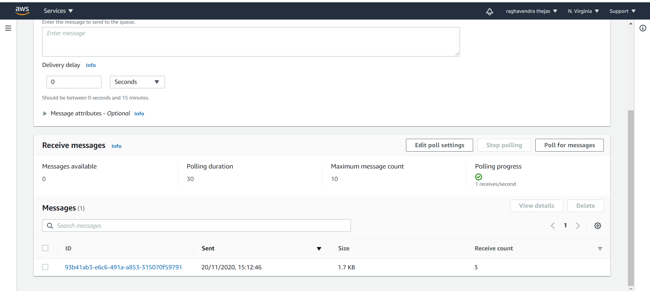

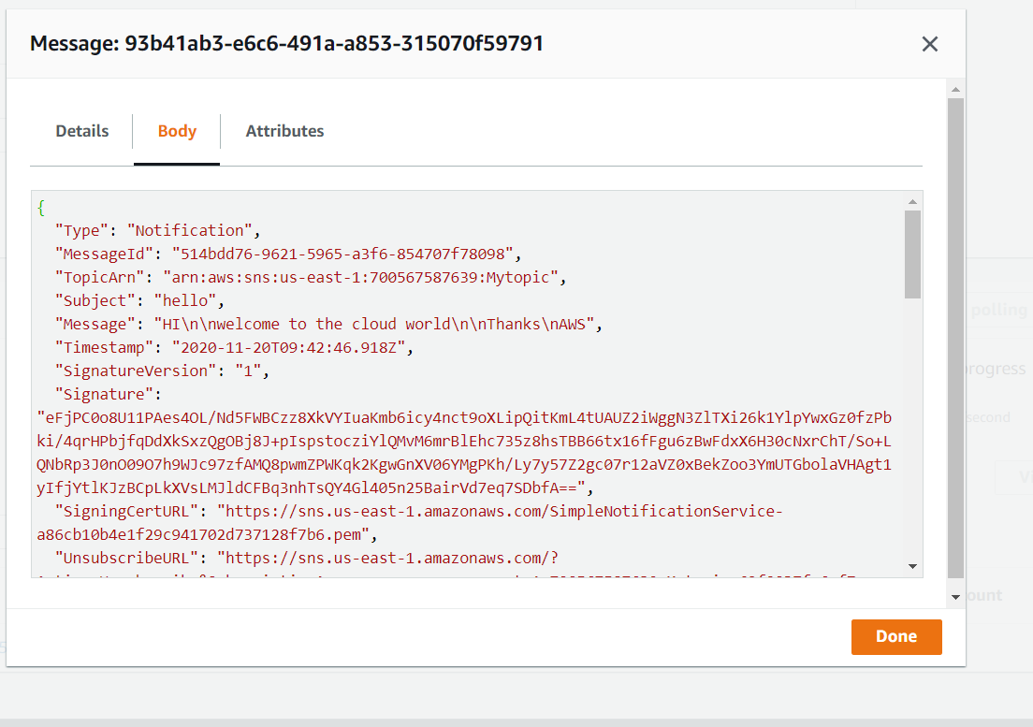

Next page

Task 3:Working with SES

ss1:inbox mail verification

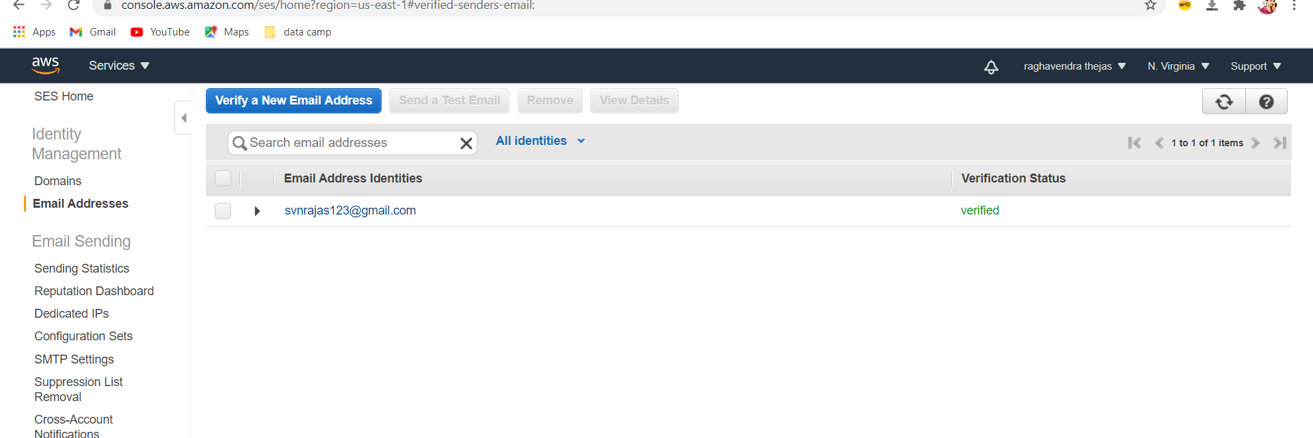

Task 4:TRIGGERING CLOUDWATCH EVENT SNS NOTIFICATION

ss1: ec2 console

ss2: rule configuration

ss3: sns topic

ss4: state change event notification in your mailbox

Since cloudwatch activities will create the bills avoiding this task as per madam suggestion